AP Computer Science _______ Name ___________________________

Tests: 2D array 35 points Date ________________ Period ______

ArrayList, Tricky Polymorphism

AP Quick Reference Sheet Allowed

**Multiple Choice (1 point each): Choose the best answer and circle it on your quiz.**

1. Consider the following method.

public ArrayList<Integer> mystery(int n)

{

ArrayList<Integer> seq = new ArrayList<Integer>();

for (int k=1; k<= n; k++)

seq.add(new Integer(k * k +3));

return seq;

}

Which of the following is printed as a result of executing the following statement?

System.out.println(mystery(6));

a) [3,4,7,12,19,28]

b) [39,28,19,12,7,4,3]

c) [39,28,19,12,7, 4]

d) [4,7,12,19,28,39]

e) [3,4,7,12,19,28,39]

2. Assume that words is an ArrayList<String> and that val is a non-null String variable.

Consider the following code segment:

boolean tmp = false;

for(String word: words) {

if(val.equals(word)) {

tmp = true;

}

}

Which of the following best characterizes the conditions under which tmp

is assigned true?

1. Whenever exactly one item in words is equal to val
2. Whenever the first item in words is equal to val
3. Whenever more than one item in words is equal to val
4. Whenever the last item in words is equal to val
5. Whenever words contains val

3. What is the output of the following code segment?

List<String> list = new ArrayList<String>();

list.add("A");

list.add("B");

list.add("C");

list.add("D");

list.add("E");

for (int k = 1; k <= 3; k++)

list.remove(1);

for (int k = 1; k <= 3; k++)

list.add(1, "*");

System.out.println(list);

1. IndexOutOfBoundsException
2. [*, *, *, B, C, D, E­­]
3. [A, *, *, *, E]
4. [*, *, *, D, E]
5. [A, *, *, *, C, D, E]

4.  Consider the following code segment.

  int[][] values = {{6, 5, 4}, {3, 2, 1}};

int x = 0;

for (int j = 0; j < values.length; j++) {

for (int k = 0; k < values[0].length; k++) {

if (k == 0) {

  values[j][k] *= 2;

}

x += values[j][k];

}

}

What is the value of x after the code is executed?

A. 9

B. 16

C. 21

D. 26

E. 30

5. Consider a class that has this private instance variable:

private int[][] mat;

The class has the following method, modify.

public void modify(int c)

{

for (int i = 0; i < mat.length; i++)

for (int j = c + 1; j < mat[0].length; j++)

mat[i][j-1] = mat[i][j];

}

If a 3 x 4 matrix mat is

1 3 5 7

2 4 6 8

3 5 7 9

Then modify(1) will change mat to

A. 1 5 7 7

2 6 8 8

3 7 9 9

B. 1 5 7

2 6 8

3 7 9

C. 1 3 5 7

3 5 7 9

D. 1 3 5 7

3 5 7 9

3 5 7 9

E. 1 7 7 7

2 8 8 8

3 9 9 9

**6 – 10 (1 point each) Assuming that the following classes have been defined:**

public class A

{

public void method1()

{

System.out.print("A1 ");

}

public void method3()

{

System.out.print("A3 ");

}

}

public class B extends A

{

public void method3()

{

System.out.print("B3 ");

super.method3();

}

}

public class C extends B

{

public void method2()

{

System.out.print("C2 ");

method1();

}

}

public class D extends B

{

public void method1()

{

System.out.print("D1 ");

super.method1();

}

public void method3()

{

System.out.print("D3 ");

super.method3();

}

}

And assuming the following variables have been defined:

A var1 = new C();

B var2 = new B();

A var3 = new D();

D var4 = new D();

Object var5 = new A();

In the table below, indicate in the right-hand column the output produced by the statement in the left-hand column. If the statement causes an error, fill in the right-hand column with either the phrase “compiler error” or “runtime error” to indicate when the error would be detected.

Statement Output

6. var1.method1(); _____________________________

7. var2.method3(); _____________________________

8. var1.method2(); _____________________________

9. ((B)var1).method2(); _____________________________

10. ((D)var3).method3(); _____________________________

11. Write a method, removeOdds, that accepts an **ArrayList** of Integers. It should remove all of the integers that are odd and greater than 50 in the given list. Be sure to include the method header. It does not return a new array, just changes the input arraylist. (4 points)

Example input/output:

{83, 22, 84, 75, 45} --> {22, 84, 45}

12. A Bank application maintains an ArrayList of Deposits per customer. The Deposit class is defined as:



The BankCustomer class is defined as:



a) Write the 1 argument constructor for the BankCustomer. The constructor needs to initialize the ArrayList of Deposits and any other instance variables. (2 points)

public BankCustomer(String name) {

b) Write the deposit method for the BankCustomer. The method will create and initialize a Deposit object, add it to the ArrayList of Deposits, and then update the balance field. (4 points)

public void deposit (double amount) {

c) Write the getMaxDeposit() method for the BankCustomer. The method will traverse (read each deposit in ) the ArrayList of Deposits and return the reference to the largest Deposit. If 2 or more Deposits have the same maximum value, it does not matter which one you select. If there are no Deposits, return null. (5 points)

public Deposit getMaxDeposit() {

13. Write a method, getMinimums, that is given a 2-dimensional array of integers and returns the minimum value for each row in a 1-dimensional array. The minimum values are stored in a 1-dimensional array and returned by the method. ( 5 points)

**Example Input and Output:** 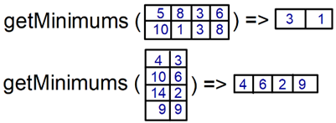

14. Write a method, flatten, that takes in a 2-dimensional array and converts it into a 1-dimensional array. The method will populate the 1-dimensional array row by row, starting from the first row. You can assume the 2-dimensional array is not jagged (all columns have the same length). Include the method header. (5 points)

**Example**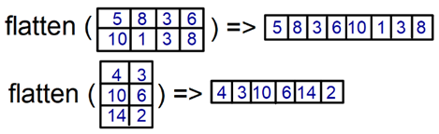

Answer Key:

1. D
2. E
3. C
4. E
5. A
6. var1.method1(); __________ A1__________________
7. var2.method3(); _____________B3 A3 ________________
8. var1.method2(); ____________Compiler Error_________________
9. ((B)var1).method2(); _________ Compiler Error____________________
10. ((D)var3).method3(); __________ D3 B3 A3 ___________________

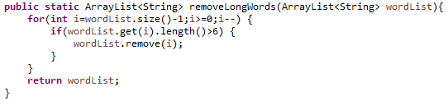

6a.

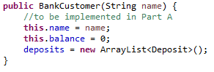

6b.

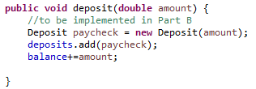

6c.

